.net and Oracle 11g Database connection:
1.Oracle:
Step1:
Login oracle 11g using the above username and password
create ur own database.(eg: username:mm password:mm)
Logout
Step2:
login with ur database -> create table ( eg. Info ( id prim key , name) )
log out

TABLES USED IN THE PROJECT
1.LOGIN TABLE:

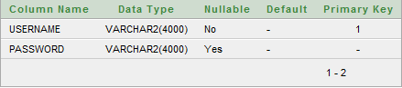
- LAB TABLE

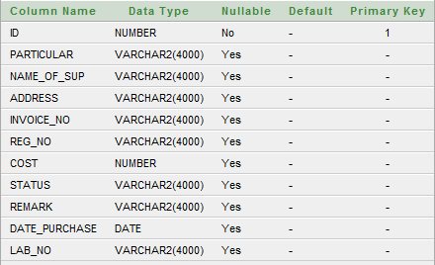

2.Design the forms

3.CONNECTION TO THE DATABASE

Step 1.add ref-> C:\oraclexe\app\oracle\product\11.2.0\server\odp.net\bin\2.x\OracleDataAccess.ddl
(From the solution explorer in .net)

Step 2.data->add data source->database->connection string
copy the connection string n paste in notepad( for later use)

Step 3.tools->connect to database->add connection->mention server name->username,password->test connection

Step 4. check the database

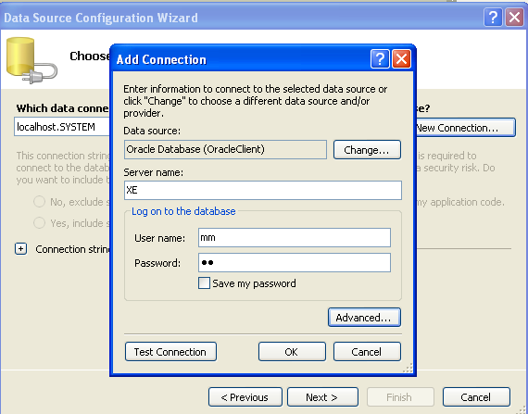

4.CODES AND SNAPSHOTS:
1.Pass values from form1 to form2:
Form1:
Public Class Form1
Dim f2 As Form2
Dim s1 As String

Private Sub Button1_Click(ByVal sender As System.Object, ByVal e As System.EventArgs) Handles Button1.Click
s1 = TextBox1.Text
f2 = New Form2(s1)
f2.Show()
Me.Hide()

End Sub
End Class

Form2:
Public Class Form2
Dim ValueFromParent As String
Public Sub New(ByVal initialValue As String)
MyBase.New()
'This call is required by the Windows Form Designer.
InitializeComponent()
ValueFromParent = initialValue
Label1.Text = ValueFromParent

End Sub
Private Sub Form2_Load(ByVal sender As System.Object, ByVal e As System.EventArgs) Handles MyBase.Load

End Sub
End Class

- LOGIN PROCESS:
LOGIN PAGE: (FORMS: LOGIN,REGISTER,LOGINBAR)
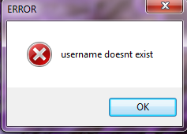
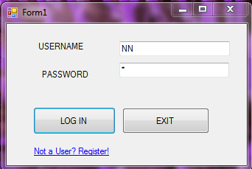

REGISTRATION FORM:
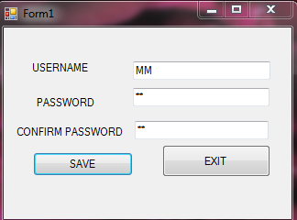
AFTER SUCCESSFUL REGISTRATION:
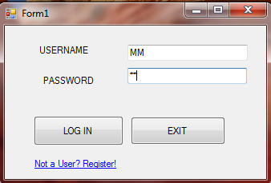
LOGIN FORM:
Imports Oracle.DataAccess.Client
Public Class LOGIN
Dim op As New LOGINBAR
Dim con1 As OracleConnection
Dim cmd As OracleCommand
Dim query As String
Dim temp As Integer

Private Sub Button2_Click(ByVal sender As System.Object, ByVal e As System.EventArgs) Handles Button2.Click
End

End Sub

Private Sub Button1_Click(ByVal sender As System.Object, ByVal e As System.EventArgs) Handles Button1.Click

If ((TextBox1.Text = " ") Or (TextBox2.Text = "")) Or ((TextBox1.Text = "lab") And (TextBox2.Text = "")) Or ((TextBox1.Text = "") And (TextBox2.Text = "lab")) Then
MsgBox(" Enter the username and password ")
Else

Dim search As String
Dim flag As Integer = 0
con1 = New OracleConnection("Data Source=XE;User ID=m;password=m")
search = "select * from login where username ='" & TextBox1.Text & "' "
cmd = New OracleCommand(search, con1)
Dim reader2 As OracleDataReader

con1.Open()
reader2 = cmd.ExecuteReader()

Do While reader2.Read()
query = reader2("password")
flag = 1
Loop
reader2.Close()

con1.Close()
If flag = 0 Then
MsgBox(" username doesnt exist", vbOKOnly + vbCritical, "ERROR")

ElseIf TextBox2.Text = query Then
op.Show()
Me.Hide()

Else
MsgBox("Username and Password doesnt match.Please enter correct username and Password")
TextBox2.Text = " "
TextBox2.Focus()
End If

End If

End Sub

Private Sub LOGIN_Load(ByVal sender As System.Object, ByVal e As System.EventArgs) Handles MyBase.Load
TextBox1.Focus()

End Sub

Private Sub LinkLabel1_LinkClicked(ByVal sender As System.Object, ByVal e As System.Windows.Forms.LinkLabelLinkClickedEventArgs) Handles LinkLabel1.LinkClicked
Dim r As New register
r.Show()
Me.Hide()

End Sub
End Class

REGISTER FORM:
Imports Oracle.DataAccess.Client

Public Class register
Dim con1 As OracleConnection
Dim cmd As OracleCommand
Dim query As String
Dim temp, I As Integer
Dim reader2 As OracleDataReader
Private Sub Button1_Click(ByVal sender As System.Object, ByVal e As System.EventArgs) Handles Button1.Click
If TextBox1.Text = "" Or TextBox2.Text = "" Or TextBox3.Text = "" Then
temp = MsgBox("Enter All the Details", vbOKOnly + vbCritical, "ERROR")
Else
If TextBox2.Text = TextBox3.Text Then
I = 0

query = "select * from login where username='" & TextBox1.Text & "' "
con1.Open()
cmd = New OracleCommand(query, con1)

reader2 = cmd.ExecuteReader()

Do While reader2.Read()
If (reader2("username") = TextBox1.Text) Then
I = 1
Else
I = I
End If
Loop
reader2.Close()
con1.Close()

If I = 1 Then
MsgBox(" username exists", vbOKOnly + vbCritical, "ERROR")
TextBox1.Text = " "
TextBox1.Focus()
Else
con1.Open()
query = "Insert into login values('" & TextBox1.Text & "','" & TextBox2.Text & "')"
cmd = New OracleCommand(query, con1)
cmd.CommandType = CommandType.Text
temp = cmd.ExecuteNonQuery()
If temp > 0 Then
MsgBox(" RECORD ADDED SUCESSFULLY", vbOKOnly, "MESSAGE")

Else
MsgBox(" INSERT OPERATION FAILED", vbOKOnly + vbCritical, "ERROR")
End If
TextBox1.Text = ""
TextBox2.Text = ""
TextBox3.Text = ""
End If

Else
temp = MsgBox("PASSWORDS DO NOT MATCH", vbOKOnly + vbCritical, "ERROR")
TextBox2.Text = ""
TextBox3.Text = ""
TextBox2.Focus()

End If
End If
End Sub

Private Sub Button2_Click(ByVal sender As System.Object, ByVal e As System.EventArgs) Handles Button2.Click
Dim l As New LOGIN
l.Show()
Me.Hide()

End Sub

Private Sub register_Load(ByVal sender As System.Object, ByVal e As System.EventArgs) Handles MyBase.Load
con1 = New OracleConnection("Data Source=XE;User ID=m;password=m")
End Sub
End Class

LOGINBAR FORM
Public Class LOGINBAR
Dim OPFRM As New optionFrm

Private Sub BAR_Load(ByVal sender As System.Object, ByVal e As System.EventArgs) Handles MyBase.Load
ProgressBar1.Step = 21
ProgressBar1.Value = 0

Timer1.Enabled = True

End Sub

Private Sub Timer1_Tick(ByVal sender As System.Object, ByVal e As System.EventArgs) Handles Timer1.Tick
ProgressBar1.PerformStep()
Label1.Text = " LOADING....." + ProgressBar1.Value.ToString + " % COMPLETED"
If ProgressBar1.Value >= ProgressBar1.Maximum Then
Timer1.Enabled = False

OPFRM.Show()
Me.Hide()
End If

End Sub
End Class

OPTION FORM:
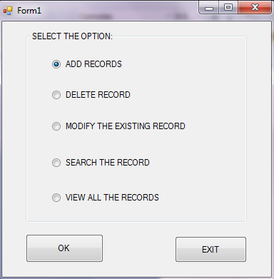
Public Class optionFrm
Dim ADD1 As New ADD
Dim SFRM As SEARCH
Dim VFRM As New VIEW
Dim dfrm As New delete

Private Sub Button1_Click(ByVal sender As System.Object, ByVal e As System.EventArgs) Handles Button1.Click
If RadioButton1.Checked = True Then
ADD1.Show()
Me.Hide()

End If

If RadioButton2.Checked = True Then

dfrm.Show()
Me.Hide()
End If
If RadioButton3.Checked = True Then
SFRM = New SEARCH() ‘ SEARCH FRM HAS DIFF CONSTRUCTORS(CALLIN 1ST CONSTRUCTOR **)
SFRM.Show()
Me.Hide()
End If

If RadioButton4.Checked = True Then
SFRM = New SEARCH() ‘ SEARCH FRM HAS DIFF CONSTRUCTOR(CALLIN 1ST CONSTRUCTOR **)
SFRM.Show()
Me.Hide()
End If

If RadioButton5.Checked = True Then

VFRM.Show()
Me.Hide()

End If

End Sub

Private Sub Button2_Click(ByVal sender As System.Object, ByVal e As System.EventArgs) Handles Button2.Click
End

End Sub
End Class

** REFER SEARCH FORM CODE
ADD PROCESS: ( ADD FORM)
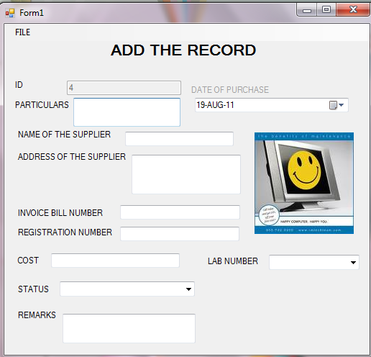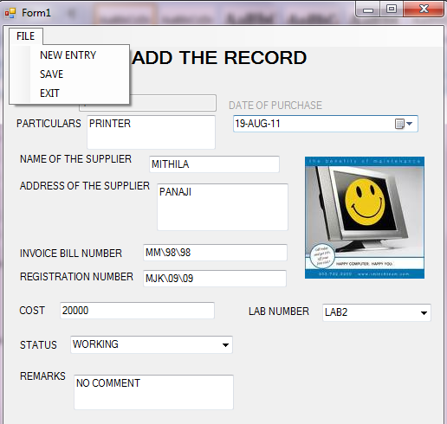
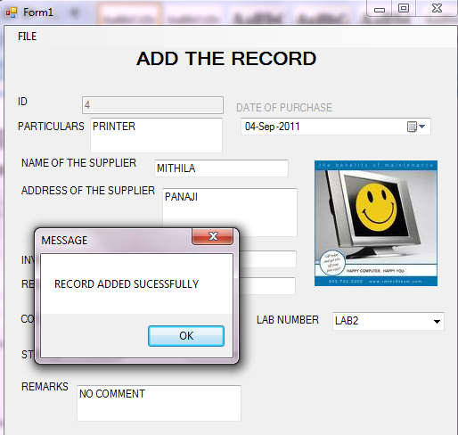

Imports Oracle.DataAccess.Client
Public Class ADD
Dim con1 As OracleConnection
Dim cmd As OracleCommand
Dim query As String
Dim temp As Integer
Private Sub EXITToolStripMenuItem_Click(ByVal sender As System.Object, ByVal e As System.EventArgs) Handles EXITToolStripMenuItem.Click
Dim OP As New optionFrm
OP.Show()
Me.Hide()

End Sub

Public Sub NEWRECORD() ‘ USER DEFINED FUNCTION TO GET THE NEXT VALID ID
Dim query2 As String
Dim ID As String
query2 = "Select max(id) from LAB"
con1.Open()
cmd = New OracleCommand(query2, con1)
cmd.CommandText = query2
ID = cmd.ExecuteScalar().ToString
If (ID.Equals("")) Then
TextBox1.Text = 1
Else
TextBox1.Text = Val(ID) + 1
End If
con1.Close()
End Sub

Private Sub NEWENTRYToolStripMenuItem_Click(ByVal sender As System.Object, ByVal e As System.EventArgs) Handles NEWENTRYToolStripMenuItem.Click

Call NEWRECORD()

End Sub

Public Sub CLEARFORM() ‘ USER DEFINED FUNCTION TO CLEAR THE FORM
TextBox2.Text = ""
TextBox3.Text = ""
TextBox4.Text = ""
TextBox5.Text = ""
TextBox6.Text = ""
TextBox7.Text = ""
TextBox8.Text = ""
ComboBox1.SelectedIndex = 0
ComboBox2.SelectedIndex = 0
DateTimePicker1.Text = Date.Now
TextBox2.Focus()
End Sub

Private Sub ADD_Load(ByVal sender As System.Object, ByVal e As System.EventArgs) Handles MyBase.Load

con1 = New OracleConnection("Data Source=XE;User ID=m;password=m")
Call NEWRECORD()
Call CLEARFORM()
DateTimePicker1.Format = DateTimePickerFormat.Custom
DateTimePicker1.CustomFormat = " dd-MMM-yyyy "

End Sub

Private Sub SAVEToolStripMenuItem_Click(ByVal sender As System.Object, ByVal e As System.EventArgs) Handles SAVEToolStripMenuItem.Click

If (TextBox1.Text = "" Or TextBox2.Text = "" Or TextBox3.Text = "" Or TextBox4.Text = "" Or TextBox5.Text = "" Or TextBox6.Text = "" Or TextBox7.Text = "" Or ComboBox1.Text = "SELECT STATUS" Or TextBox8.Text = "" Or DateTimePicker1.Text = " " Or ComboBox2.Text = "SELECT LAB") Then

temp = MsgBox("Enter All the Details", vbOKOnly + vbCritical, "ERROR")

Else

DateTimePicker1.Format = DateTimePickerFormat.Custom
DateTimePicker1.CustomFormat = " dd-MMM-yyyy "

Try

con1.Open()

query = "Insert into LAB values('" & Val(TextBox1.Text) & "','" & TextBox2.Text & "','" & TextBox3.Text.ToUpper & "','" & TextBox4.Text & "','" & TextBox5.Text & "','" & TextBox6.Text & "','" & Val(TextBox7.Text) & "','" & ComboBox1.Text & "','" & TextBox8.Text & "','" & DateTimePicker1.Text & "','" & ComboBox2.Text & "')"

cmd = New OracleCommand(query, con1)
cmd.CommandType = CommandType.Text
temp = cmd.ExecuteNonQuery()
If temp > 0 Then
MsgBox(" RECORD ADDED SUCESSFULLY", vbOKOnly, "MESSAGE")
Call CLEARFORM()
Else
MsgBox(" INSERT OPERATION FAILED", vbOKOnly + vbCritical, "ERROR")
End If
Catch ex As Exception
temp = MsgBox(ex.ToString, vbOK + vbCritical, "ERROR!")
End Try

End If

con1.Close()
Call NEWRECORD()
End Sub

End Class

SEARCHING, DELETION AND MODIFYING PROCESS: ( SEARCH FORM AND SEARCHBAR FORM)
- SEARCH:
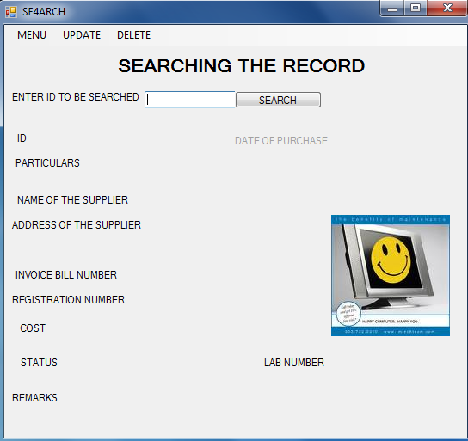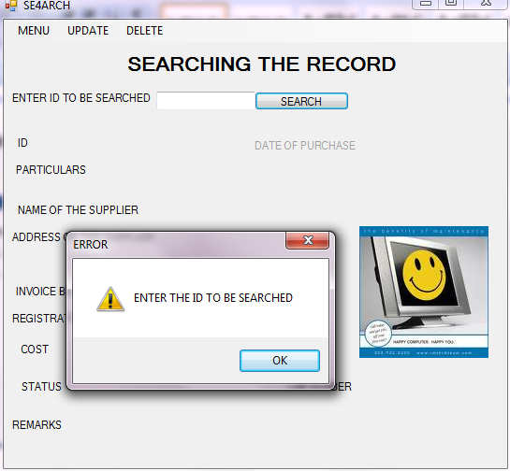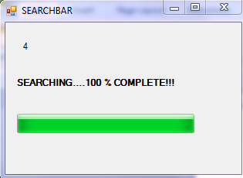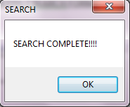
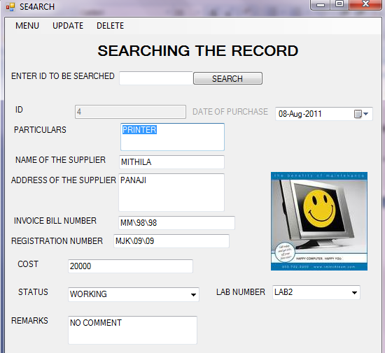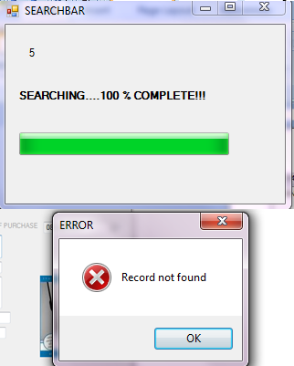

SEARCH FORM:
Imports Oracle.DataAccess.Client
Public Class SEARCH
Dim OP As New optionFrm
Dim con1 As OracleConnection
Dim cmd As OracleCommand
Dim query As String
Dim temp, I As Integer
Dim reader2 As OracleDataReader

Public Sub New() ‘ 1ST CONSTRUCTOR WIDOUT ARGUMENTS
MyBase.New()
'This call is required by the Windows Form Designer.
InitializeComponent()
Call NSEARCH()
TextBox9.Focus()
TextBox9.Focus()

End Sub

Public Sub New(ByVal str1 As String) ‘ 2ND CONSTRUCTOR WID 1 ARGUMENT STR1( ID VALUE)
'MyBase.New()
'This call is required by the Windows Form Designer.
InitializeComponent()
TextBox1.Visible = True
TextBox2.Visible = True
TextBox3.Visible = True
TextBox4.Visible = True
TextBox5.Visible = True
TextBox6.Visible = True
TextBox7.Visible = True
TextBox8.Visible = True
ComboBox1.Visible = True
ComboBox2.Visible = True
DateTimePicker1.Visible = True
DateTimePicker1.Format = DateTimePickerFormat.Custom
DateTimePicker1.CustomFormat = " dd-MMM-yyyy "
TextBox9.Text = str1
Dim search As String
Dim flag As Integer = 0
con1 = New OracleConnection("Data Source=XE;User ID=m;password=m")
search = "select * from LAB where ID='" & TextBox9.Text & "' "
cmd = New OracleCommand(search, con1)

con1.Open()
reader2 = cmd.ExecuteReader()

Do While reader2.Read()
TextBox1.Text = reader2("ID")
TextBox2.Text = reader2("PARTICULAR")
TextBox3.Text = reader2("NAME_OF_SUP")
TextBox4.Text = reader2("ADDRESS")
TextBox5.Text = reader2("INVOICE_NO")
TextBox6.Text = reader2("REG_NO")
TextBox7.Text = reader2("COST")
TextBox8.Text = reader2("REMARK")
ComboBox1.Text = reader2("STATUS")
ComboBox2.Text = reader2("LAB_NO")
DateTimePicker1.Text = reader2("DATE_PURCHASE").ToString
flag = 1
Loop
If flag = 0 Then
MsgBox(" Record not found", vbOKOnly + vbCritical, "ERROR")
Call NSEARCH()

End If
reader2.Close()
con1.Close()
TextBox9.Text = " "
TextBox9.Focus()

End Sub
Private Sub SEARCH_Load(ByVal sender As System.Object, ByVal e As System.EventArgs) Handles MyBase.Load
DateTimePicker1.Format = DateTimePickerFormat.Custom
DateTimePicker1.CustomFormat = " dd-MMM-yyyy "
End Sub

Private Sub EXITToolStripMenuItem_Click(ByVal sender As System.Object, ByVal e As System.EventArgs) Handles EXITToolStripMenuItem.Click
OP.Show()
Me.Hide()

End Sub

Private Sub NEWSEARCHToolStripMenuItem_Click(ByVal sender As System.Object, ByVal e As System.EventArgs) Handles NEWSEARCHToolStripMenuItem.Click
Call NSEARCH()

End Sub

Public Sub NSEARCH()
TextBox1.Visible = False
TextBox2.Visible = False
TextBox3.Visible = False
TextBox4.Visible = False
TextBox5.Visible = False
TextBox6.Visible = False
TextBox7.Visible = False
TextBox8.Visible = False
ComboBox1.Visible = False
ComboBox2.Visible = False
DateTimePicker1.Visible = False
End Sub

Private Sub Button1_Click(ByVal sender As System.Object, ByVal e As System.EventArgs) Handles Button1.Click

Dim SBAR As SEARCHBAR

If TextBox9.Text = "" Or TextBox9.Text = " " Then
MsgBox("ENTER THE ID TO BE SEARCHED", vbOKOnly + vbExclamation, "ERROR")

Else

SBAR = New SEARCHBAR(TextBox9.Text)
SBAR.Show()
Me.Hide()

End If

End Sub

MODIFYING CODE:

Private Sub MODIFYToolStripMenuItem_Click(ByVal sender As System.Object, ByVal e As System.EventArgs) Handles MODIFYToolStripMenuItem.Click

If (TextBox1.Visible = False) Then

MsgBox("SEARCH THE RECORD FIRST ", vbOKOnly + vbExclamation, "ERROR")
Else
temp = MsgBox("ARE YOU SURE YOU WANT TO MODIFY THE RECORD?", vbOKCancel + vbQuestion, "WARNING")
If temp = vbOK Then
query = "Update LAB Set PARTICULAR='" & TextBox2.Text & "',NAME_OF_SUP='" & TextBox3.Text.ToUpper & "',ADDRESS='" & TextBox4.Text & "',INVOICE_NO='" & TextBox5.Text & "',REG_NO='" & TextBox6.Text & "',COST='" & Val(TextBox7.Text) & "',REMARK='" & TextBox8.Text & "',STATUS='" & ComboBox1.Text & "',LAB_NO='" & ComboBox2.Text & "',DATE_PURCHASE='" & DateTimePicker1.Text & "' Where ID='" & TextBox1.Text & "'"

cmd = New OracleCommand(query, con1)
cmd.CommandType = CommandType.Text
Try
con1.Open()
cmd.ExecuteNonQuery()
MsgBox("Record updated successfully", vbOKOnly, "MESSAGE")
Catch er As Exception
MsgBox(er.Message)
Finally
If (Not con1 Is Nothing) Then
con1.Close()
End If
End Try

End If

End If
Call NSEARCH()
End Sub

DELETE CODE:

Private Sub DELETEToolStripMenuItem_Click(ByVal sender As System.Object, ByVal e As System.EventArgs) Handles DELETEToolStripMenuItem.Click
If (TextBox1.Visible = False) Then

MsgBox("SEARCH THE RECORD FIRST ", vbOKOnly + vbExclamation, "ERROR")
Else
temp = MsgBox("ARE YOU SURE YOU WANT TO DELETE?", vbOKCancel + vbQuestion, "WARNING")
If temp = vbOK Then

I = 0

query = "select * from LAB where ID='" & TextBox1.Text & "' "
con1.Open()
cmd = New OracleCommand(query, con1)

reader2 = cmd.ExecuteReader()

Do While reader2.Read()
If (reader2("ID") = TextBox1.Text) Then
I = 1
Else
I = I
End If
Loop
reader2.Close()
con1.Close()

If I = 0 Then
MsgBox(" Record not found", vbOKOnly + vbCritical, "ERROR")
TextBox1.Text = " "
Else

con1.Open()
Dim del As String
del = "delete from LAB where ID='" & TextBox1.Text & "' "
cmd = New OracleCommand(del, con1)
I = cmd.ExecuteNonQuery()
MessageBox.Show("Item Successfully Deleted")
TextBox1.Text = ""
con1.Close()

End If

Else
TextBox1.Text = ""

End If
End If

End Sub
End Class

SEARCHBAR FORM:
Imports Oracle.DataAccess.Client
Public Class SEARCHBAR
Dim SFRM As SEARCH

Private Sub SEARCHBAR_Load(ByVal sender As System.Object, ByVal e As System.EventArgs) Handles MyBase.Load
ProgressBar1.Step = 21
ProgressBar1.Value = 0

Timer1.Enabled = True
End Sub

Private Sub Timer1_Tick(ByVal sender As System.Object, ByVal e As System.EventArgs) Handles Timer1.Tick
ProgressBar1.PerformStep()
Label2.Text = "SEARCHING...." + ProgressBar1.Value.ToString + " % COMPLETE!!!"
If ProgressBar1.Value >= ProgressBar1.Maximum Then
Timer1.Enabled = False
MsgBox("SEARCH COMPLETE!!!!", vbOKOnly, "SEARCH")
SFRM = New SEARCH(Label1.Text)
SFRM.Show()
Me.Hide()
End If

End Sub
Public Sub New(ByVal i As String)
MyBase.New()
'This call is required by the Windows Form Designer.
InitializeComponent()
Label1.Text = i

End Sub
End Class

DISPLAYING THE RECORDS IN THE DATA GRID: (VIEW FORM)
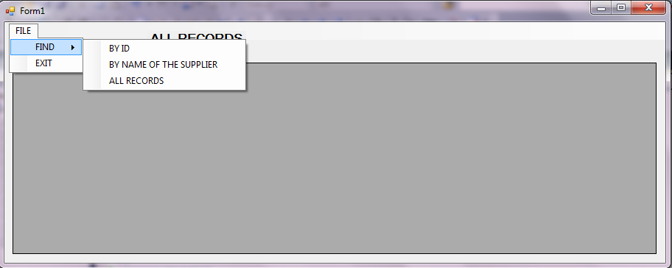
VIEW ALL RECORDS:
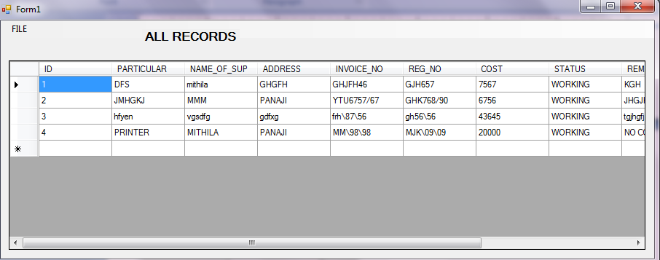

VIEW RECORD: SEARCHIN BY ID:
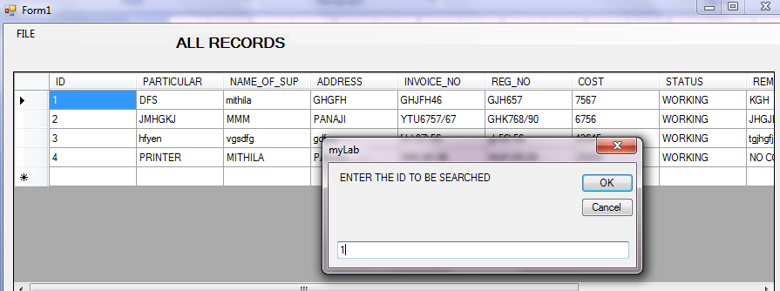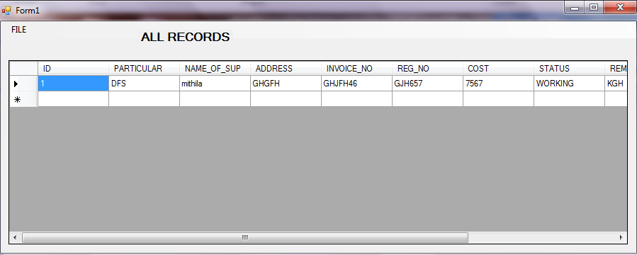

VIEW RECORD: SEARCHING BY NAME OF SUPPLIER:
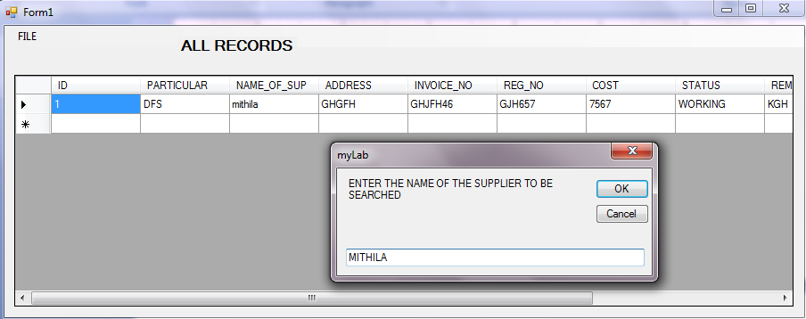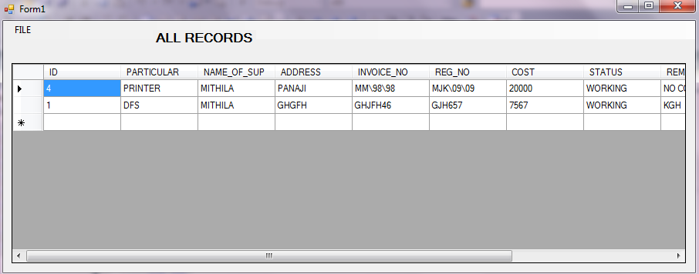
VIEW FORM CODE:
Imports Oracle.DataAccess.Client
Public Class VIEW
Dim con1 As OracleConnection
Dim cmd As OracleCommand
Dim query As String
Dim temp As Integer
Dim da As OracleDataAdapter
Dim d As DataSet
Private Sub VIEW_Load(ByVal sender As System.Object, ByVal e As System.EventArgs) Handles MyBase.Load
con1 = New OracleConnection("data source =XE;user id=m;password=m")

End Sub

Private Sub EXITToolStripMenuItem_Click(ByVal sender As System.Object, ByVal e As System.EventArgs) Handles EXITToolStripMenuItem.Click
Dim OP As NEW optionFrm()
OP.Show()
Me.Hide()
End Sub

Private Sub BYIDToolStripMenuItem_Click(ByVal sender As System.Object, ByVal e As System.EventArgs) Handles BYIDToolStripMenuItem.Click
Dim S As String

S = InputBox("ENTER THE ID TO BE SEARCHED")
If (S <> "") Then
MsgBox(S)
query = "select * from LAB WHERE ID= '" & S & "'"

cmd = New OracleCommand(query, con1)

Try
con1.Open()
da = New OracleDataAdapter(query, con1)
d = New DataSet()
da.Fill(d, "test")
DataGridView1.DataSource = d.Tables(0)
Catch EX As Exception
MsgBox(EX.ToString, vbOK)

End Try
con1.Close()
End If

End Sub

Private Sub BYNAMEOFTHESUPPLIERToolStripMenuItem_Click(ByVal sender As System.Object, ByVal e As System.EventArgs) Handles BYNAMEOFTHESUPPLIERToolStripMenuItem.Click
Dim S As String

S = InputBox("ENTER THE NAME OF THE SUPPLIER TO BE SEARCHED")
If (S <> "") Then
MsgBox(S)

query = "select * from LAB WHERE NAME_OF_SUP LIKE '" & S.ToUpper & "%'"

cmd = New OracleCommand(query, con1)

Try
con1.Open()
da = New OracleDataAdapter(query, con1)
d = New DataSet()
da.Fill(d, "test")
DataGridView1.DataSource = d.Tables(0)
Catch EX As Exception
MsgBox(EX.ToString, vbOK)

End Try
con1.Close()
End If
End Sub

Private Sub ALLRECORDSToolStripMenuItem_Click(ByVal sender As System.Object, ByVal e As System.EventArgs) Handles ALLRECORDSToolStripMenuItem.Click

Try
con1.Open()
query = "select * from LAB order by ID"

cmd = New OracleCommand(query, con1)

da = New OracleDataAdapter(query, con1)
d = New DataSet()
da.Fill(d, "test")
DataGridView1.DataSource = d.Tables(0)
Catch EX As Exception
MsgBox(EX.ToString, vbOK)

End Try
con1.Close()
End Sub

End Class

